Practical No.6
Aim: Develop a program to implement linear layout (Vertical).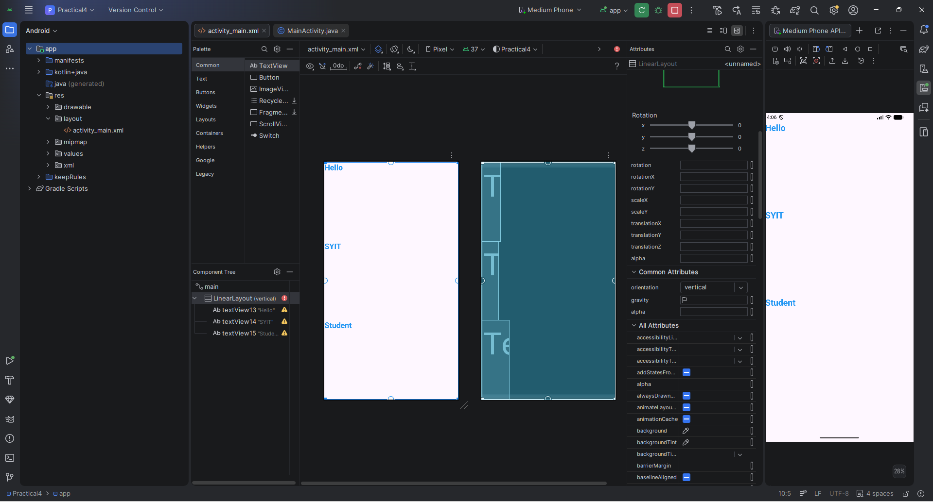
XML Code:
<?xml version=”1.0” encoding=”utf-8”?>
<ndroid.constraintlayout.widget.ConstraintLayout xmlns:android=”http://schemas.android.com/apk/res/android”
xmlns:app=”http://schemas.android.com/apk/res-auto”
xmlns:tools=”http://schemas.android.com/tools”
android:id=”@+id/main”
android:layout_width=”match_parent”
android:layout_height=”match_parent”
tools:context=”.MainActivity” >
<LinearLayout
android:layout_width=”409dp”
android:layout_height=”729dp”
android:orientation=”vertical”
tools:layout_editor_absoluteX=”1dp”
tools:layout_editor_absoluteY=”1dp”>
<TextView
android:id=”@+id/textView13”
android:layout_width=”wrap_content”
android:layout_height=”wrap_content”
android:layout_weight=”1”
android:text=”Hello”
android:textColor=”#2196F3”
android:textSize=”24sp”
android:textStyle=”bold” />
<TextView
android:id=”@+id/textView14”
android:layout_width=”wrap_content”
android:layout_height=”wrap_content”
android:layout_weight=”1”
android:text=”SYIT”
android:textColor=”#2196F3”
android:textSize=”24sp”
android:textStyle=”bold” />
<TextView
android:id=”@+id/textView15”
android:layout_width=”wrap_content”
android:layout_height=”wrap_content”
android:layout_weight=”1”
android:text=”Student”
android:textColor=”#2196F3”
android:textSize=”24sp”
android:textStyle=”bold” />
</LinearLayout>
</ndroid.constraintlayout.widget.ConstraintLayout>

JAVA Code:
package com.example.practical4;
import android.os.Bundle;
import ndroid.activity.EdgeToEdge;
import ndroid.appcompat.app.AppCompatActivity;
import ndroid.core.graphics.Insets;
import ndroid.core.view.ViewCompat;
import ndroid.core.view.WindowInsetsCompat;
public class MainActivity extends AppCompatActivity {
@Override
protected void onCreate(Bundle savedInstanceState) {
super.onCreate(savedInstanceState);
EdgeToEdge.enable(this);
setContentView(R.layout.activity_main);
ViewCompat.setOnApplyWindowInsetsListener(findViewById(R.id.main), (v, insets) -> {
Insets systemBars = insets.getInsets(WindowInsetsCompat.Type.systemBars());
v.setPadding(systemBars.left, systemBars.top, systemBars.right, systemBars.bottom);
return insets;
});
}
}

Output:

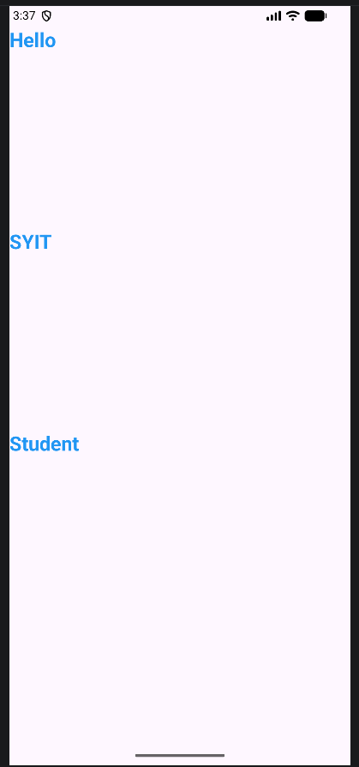

Prcatical No5
Aim: Develop a program to implement linear layout (Horizontal).
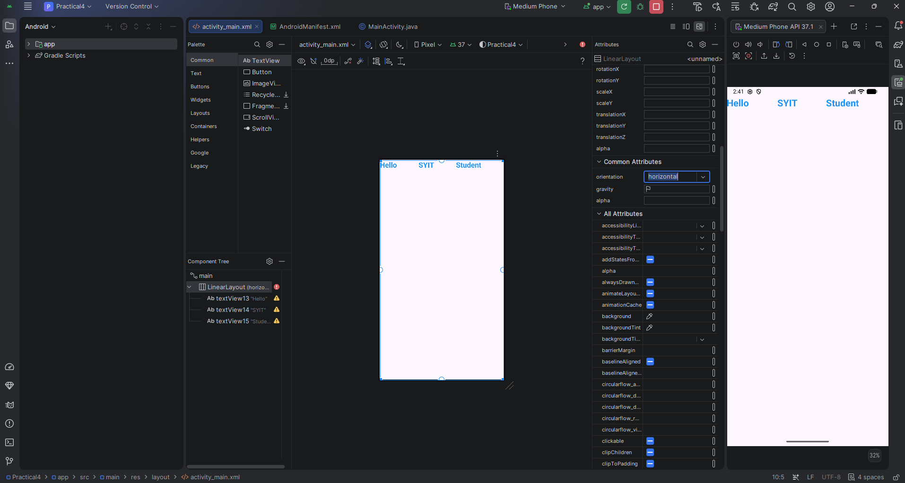
XML Code:
<?xml version="1.0" encoding="utf-8"?>
<androidx.constraintlayout.widget.ConstraintLayout xmlns:android="http://schemas.android.com/apk/res/android"
xmlns:app="http://schemas.android.com/apk/res-auto"
xmlns:tools="http://schemas.android.com/tools"
android:id="@+id/main"
android:layout_width="match_parent"
android:layout_height="match_parent"
tools:context=".MainActivity" >
<LinearLayout
android:layout_width="409dp"
android:layout_height="729dp"
android:orientation="horizontal"
tools:layout_editor_absoluteX="1dp"
tools:layout_editor_absoluteY="1dp">
<TextView
android:id="@+id/textView13"
android:layout_width="wrap_content"
android:layout_height="wrap_content"
android:layout_weight="1"
android:text="Hello"
android:textColor="#2196F3"
android:textSize="24sp"
android:textStyle="bold" />
<TextView
android:id="@+id/textView14"
android:layout_width="wrap_content"
android:layout_height="wrap_content"
android:layout_weight="1"
android:text="SYIT"
android:textColor="#2196F3"
android:textSize="24sp"
android:textStyle="bold" />
<TextView
android:id="@+id/textView15"
android:layout_width="wrap_content"
android:layout_height="wrap_content"
android:layout_weight="1"
android:text="Student"
android:textColor="#2196F3"
android:textSize="24sp"
android:textStyle="bold" />
</LinearLayout>
</androidx.constraintlayout.widget.ConstraintLayout>

JAVA Code:
package com.example.practical4;
import android.os.Bundle;
import androidx.activity.EdgeToEdge;
import androidx.appcompat.app.AppCompatActivity;
import androidx.core.graphics.Insets;
import androidx.core.view.ViewCompat;
import androidx.core.view.WindowInsetsCompat;
public class MainActivity extends AppCompatActivity {
@Override
protected void onCreate(Bundle savedInstanceState) {
super.onCreate(savedInstanceState);
EdgeToEdge.enable(this);
setContentView(R.layout.activity_main);
ViewCompat.setOnApplyWindowInsetsListener(findViewById(R.id.main), (v, insets) -> {
Insets systemBars = insets.getInsets(WindowInsetsCompat.Type.systemBars());
v.setPadding(systemBars.left, systemBars.top, systemBars.right, systemBars.bottom);
return insets;
});
}
}

Output:

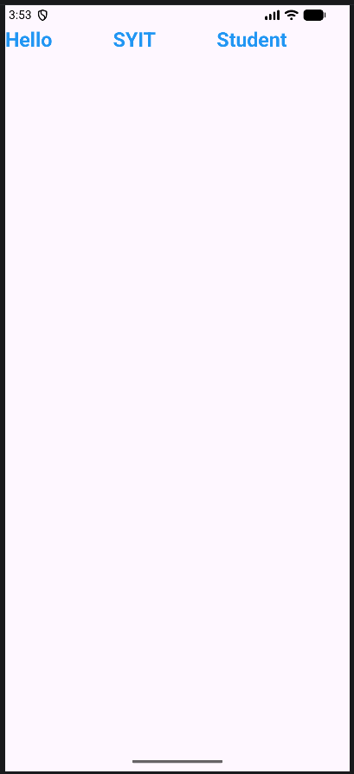

Practical No. 7
Aim: Develop a program to implement Table Layout.
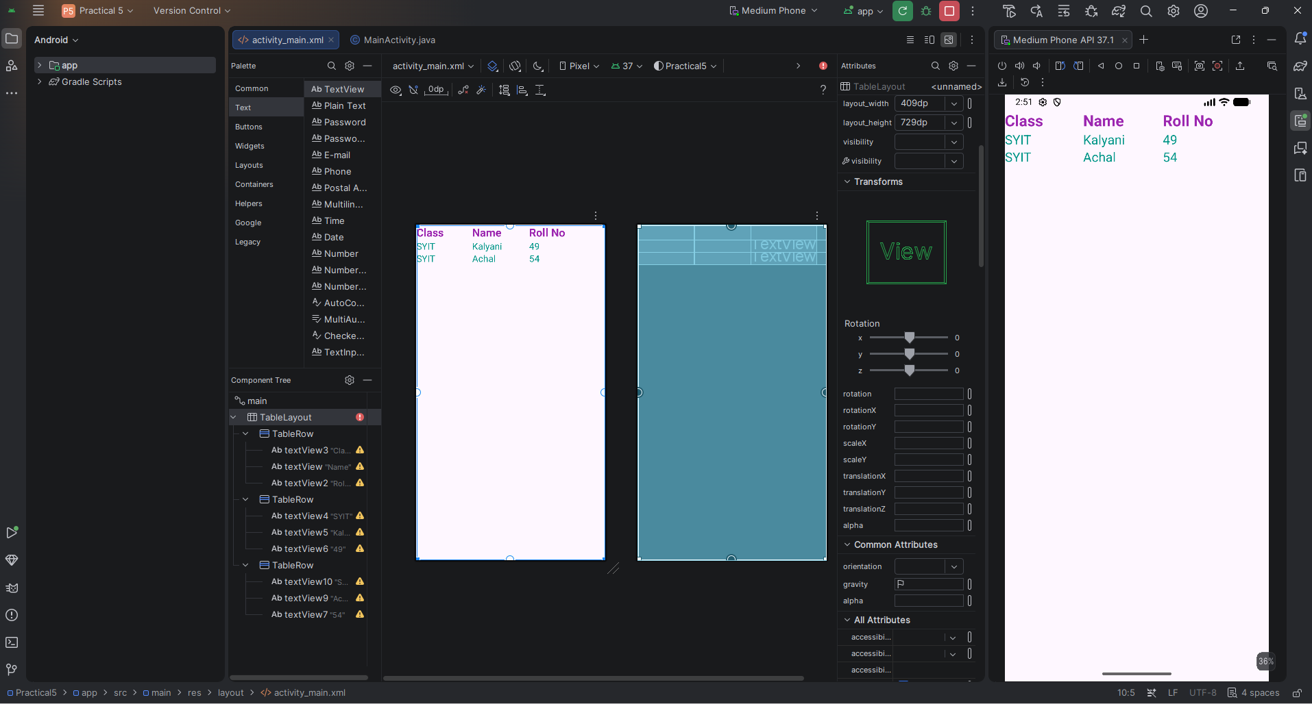

XML Code:
<?xml version="1.0" encoding="utf-8"?>
<androidx.constraintlayout.widget.ConstraintLayout xmlns:android="http://schemas.android.com/apk/res/android"
xmlns:app="http://schemas.android.com/apk/res-auto"
xmlns:tools="http://schemas.android.com/tools"
android:id="@+id/main"
android:layout_width="match_parent"
android:layout_height="match_parent"
tools:context=".MainActivity">
<TableLayout
android:layout_width="409dp"
android:layout_height="729dp"
tools:layout_editor_absoluteX="1dp"
tools:layout_editor_absoluteY="1dp">
<TableRow
android:layout_width="match_parent"
android:layout_height="match_parent" >
<TextView
android:id="@+id/textView3"
android:layout_width="122dp"
android:layout_height="wrap_content"
android:text="Class"
android:textColor="#9C27B0"
android:textSize="24sp"
android:textStyle="bold" />
<TextView
android:id="@+id/textView"
android:layout_width="124dp"
android:layout_height="wrap_content"
android:text="Name"
android:textColor="#9C27B0"
android:textSize="24sp"
android:textStyle="bold" />
<TextView
android:id="@+id/textView2"
android:layout_width="143dp"
android:layout_height="wrap_content"
android:text="Roll No"
android:textAlignment="viewStart"
android:textColor="#9C27B0"
android:textSize="24sp"
android:textStyle="bold" />
</TableRow>
<TableRow
android:layout_width="match_parent"
android:layout_height="match_parent" >
<TextView
android:id="@+id/textView4"
android:layout_width="wrap_content"
android:layout_height="wrap_content"
android:text="SYIT"
android:textAlignment="viewStart"
android:textColor="#009688"
android:textSize="20sp" />
<TextView
android:id="@+id/textView5"
android:layout_width="wrap_content"
android:layout_height="wrap_content"
android:text="Kalyani"
android:textColor="#009688"
android:textSize="20sp" />
<TextView
android:id="@+id/textView6"
android:layout_width="wrap_content"
android:layout_height="wrap_content"
android:text="49"
android:textColor="#009688"
android:textSize="20sp" />
</TableRow>
<TableRow
android:layout_width="match_parent"
android:layout_height="match_parent" >
<TextView
android:id="@+id/textView10"
android:layout_width="wrap_content"
android:layout_height="wrap_content"
android:text="SYIT"
android:textColor="#009688"
android:textSize="20sp" />
<TextView
android:id="@+id/textView9"
android:layout_width="wrap_content"
android:layout_height="wrap_content"
android:text="Achal"
android:textColor="#009688"
android:textSize="20sp" />
<TextView
android:id="@+id/textView7"
android:layout_width="wrap_content"
android:layout_height="wrap_content"
android:text="54"
android:textColor="#009688"
android:textSize="20sp" />
</TableRow>
</TableLayout>
</androidx.constraintlayout.widget.ConstraintLayout>

JAVA Code:
package com.example.practical5;
import android.os.Bundle;
import androidx.activity.EdgeToEdge;
import androidx.appcompat.app.AppCompatActivity;
import androidx.core.graphics.Insets;
import androidx.core.view.ViewCompat;
import androidx.core.view.WindowInsetsCompat;
public class MainActivity extends AppCompatActivity {
@Override
protected void onCreate(Bundle savedInstanceState) {
super.onCreate(savedInstanceState);
EdgeToEdge.enable(this);
setContentView(R.layout.activity_main);
ViewCompat.setOnApplyWindowInsetsListener(findViewById(R.id.main), (v, insets) -> {
Insets systemBars = insets.getInsets(WindowInsetsCompat.Type.systemBars());
v.setPadding(systemBars.left, systemBars.top, systemBars.right, systemBars.bottom);
return insets;
});
}
}

Output:

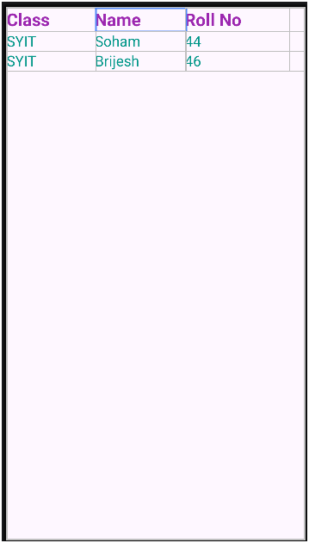

Practical No.9
Aim: Develop a program to implement Text view and Edit text
a) Without button control
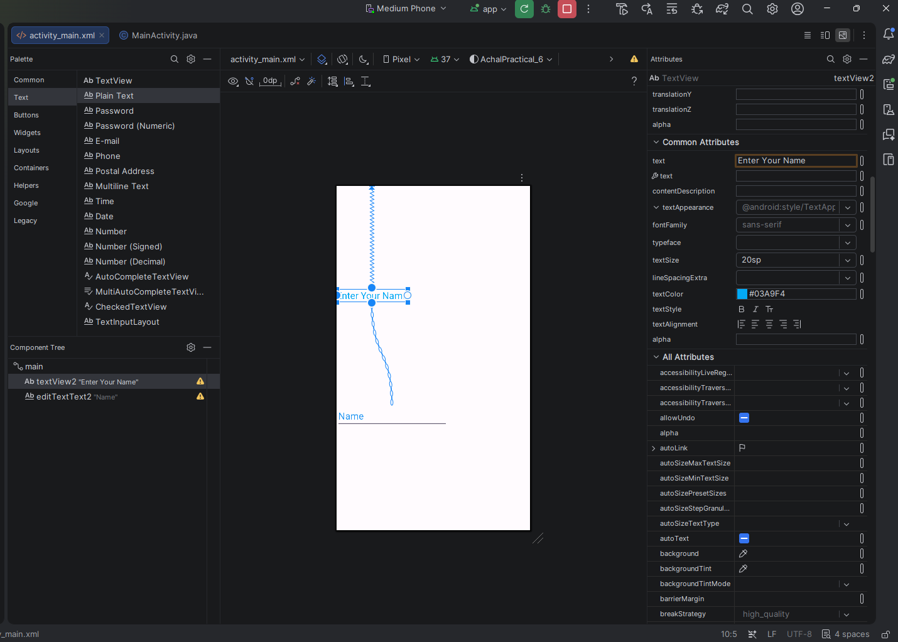
XML Code:
<?xml version="1.0" encoding="utf-8"?>
<androidx.constraintlayout.widget.ConstraintLayout xmlns:android="http://schemas.android.com/apk/res/android"
xmlns:app="http://schemas.android.com/apk/res-auto"
xmlns:tools="http://schemas.android.com/tools"
android:id="@+id/main"
android:layout_width="match_parent"
android:layout_height="match_parent"
tools:context=".MainActivity">
<TextView
android:id="@+id/textView2"
android:layout_width="wrap_content"
android:layout_height="wrap_content"
android:text="Enter Your Name"
android:textColor="#03A9F4"
android:textSize="20sp"
app:layout_constraintBottom_toTopOf="@id/editTextText2"
app:layout_constraintStart_toStartOf="parent"
app:layout_constraintTop_toTopOf="parent" />
<EditText
android:id="@+id/editTextText2"
android:layout_width="wrap_content"
android:layout_height="wrap_content"
android:ems="10"
android:inputType="text"
android:text="Name"
android:textColor="#2196F3"
android:textSize="20sp"
app:layout_constraintBottom_toBottomOf="parent"
app:layout_constraintStart_toStartOf="parent"
app:layout_constraintTop_toBottomOf="@id/textView2" />
</androidx.constraintlayout.widget.ConstraintLayout>

JAVA Code:
package com.example.achalpractical_6;
import android.os.Bundle;
import androidx.activity.EdgeToEdge;
import androidx.appcompat.app.AppCompatActivity;
import androidx.core.graphics.Insets;
import androidx.core.view.ViewCompat;
import androidx.core.view.WindowInsetsCompat;
public class MainActivity extends AppCompatActivity {
@Override
protected void onCreate(Bundle savedInstanceState) {
super.onCreate(savedInstanceState);
EdgeToEdge.enable(this);
setContentView(R.layout.activity_main);
ViewCompat.setOnApplyWindowInsetsListener(findViewById(R.id.main), (v, insets) -> {
Insets systemBars = insets.getInsets(WindowInsetsCompat.Type.systemBars());
v.setPadding(systemBars.left, systemBars.top, systemBars.right, systemBars.bottom);
return insets;
});
}
}
Output:
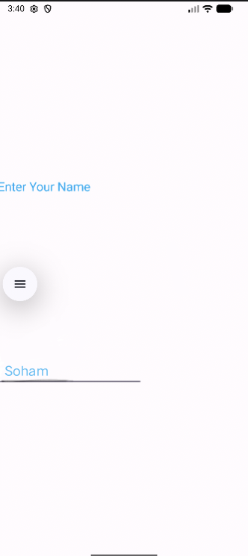

b) With Button
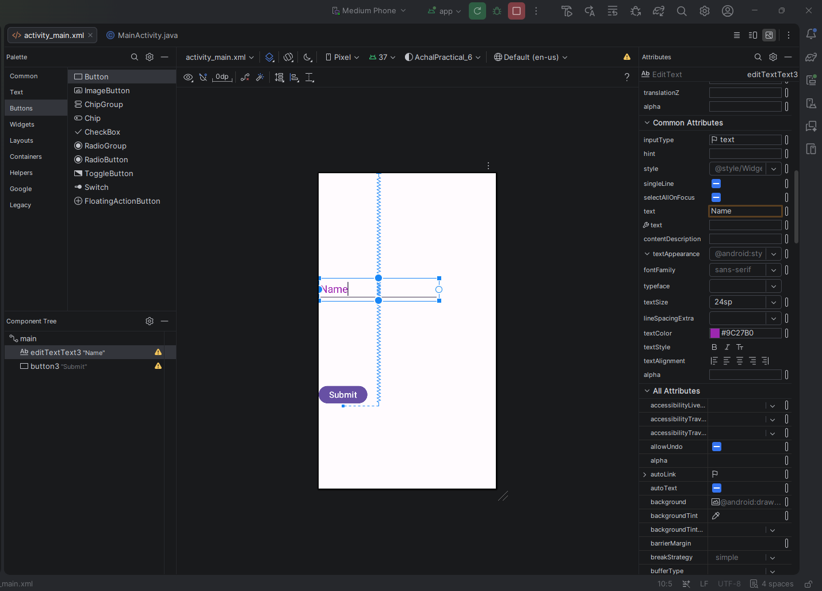

XML Code:
<?xml version="1.0" encoding="utf-8"?>
<androidx.constraintlayout.widget.ConstraintLayout xmlns:android="http://schemas.android.com/apk/res/android"
xmlns:app="http://schemas.android.com/apk/res-auto"
xmlns:tools="http://schemas.android.com/tools"
android:id="@+id/main"
android:layout_width="match_parent"
android:layout_height="match_parent"
tools:context=".MainActivity">
<EditText
android:id="@+id/editTextText3"
android:layout_width="wrap_content"
android:layout_height="wrap_content"
android:ems="10"
android:inputType="text"
android:text="Name"
android:textColor="#9C27B0"
android:textColorLink="#F44336"
android:textSize="24sp"
app:layout_constraintBottom_toTopOf="parent"
app:layout_constraintStart_toStartOf="parent"
app:layout_constraintTop_toBottomOf="@id/button3" />
<Button
android:id="@+id/button3"
android:layout_width="wrap_content"
android:layout_height="wrap_content"
android:text="Submit"
android:textSize="20sp"
app:layout_constraintBottom_toBottomOf="parent"
app:layout_constraintStart_toStartOf="parent"
app:layout_constraintTop_toBottomOf="@id/editTextText3" />
</androidx.constraintlayout.widget.ConstraintLayout>

JAVA Code:
package com.example.achalpractical_6;
import android.os.Bundle;
import androidx.activity.EdgeToEdge;
import androidx.appcompat.app.AppCompatActivity;
import androidx.core.graphics.Insets;
import androidx.core.view.ViewCompat;
import androidx.core.view.WindowInsetsCompat;
public class MainActivity extends AppCompatActivity {
@Override
protected void onCreate(Bundle savedInstanceState) {
super.onCreate(savedInstanceState);
EdgeToEdge.enable(this);
setContentView(R.layout.activity_main);
ViewCompat.setOnApplyWindowInsetsListener(findViewById(R.id.main), (v, insets) -> {
Insets systemBars = insets.getInsets(WindowInsetsCompat.Type.systemBars());
v.setPadding(systemBars.left, systemBars.top, systemBars.right, systemBars.bottom);
return insets;
});
}
}

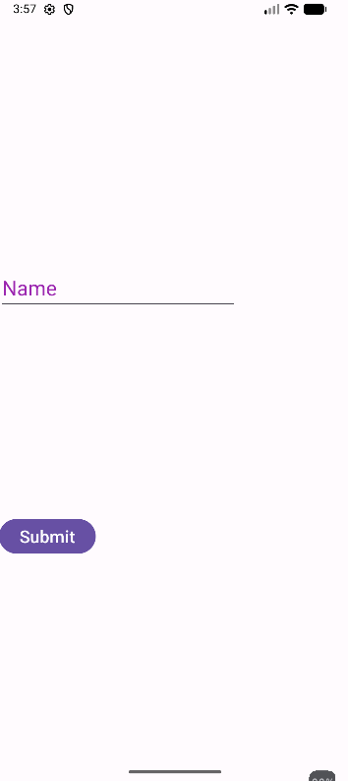

Practical No.10
Aim: Develop a program to implement Button.
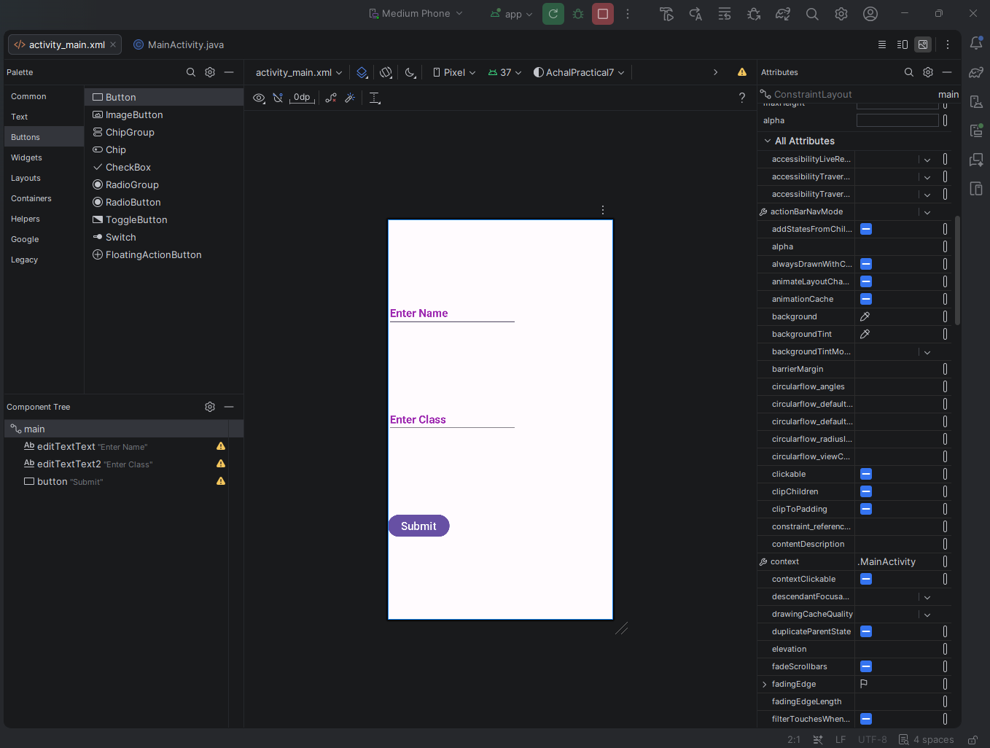

XML Code:
<?xml version="1.0" encoding="utf-8"?>
<androidx.constraintlayout.widget.ConstraintLayout xmlns:android="http://schemas.android.com/apk/res/android"
xmlns:app="http://schemas.android.com/apk/res-auto"
xmlns:tools="http://schemas.android.com/tools"
android:id="@+id/main"
android:layout_width="match_parent"
android:layout_height="match_parent"
tools:context=".MainActivity">
<EditText
android:id="@+id/editTextText"
android:layout_width="wrap_content"
android:layout_height="wrap_content"
android:ems="10"
android:inputType="text"
android:text="Enter Name"
android:textColor="#9C27B0"
android:textSize="20sp"
android:textStyle="bold"
app:layout_constraintBottom_toTopOf="@id/editTextText2"
app:layout_constraintStart_toStartOf="parent"
app:layout_constraintTop_toTopOf="parent" />
<EditText
android:id="@+id/editTextText2"
android:layout_width="wrap_content"
android:layout_height="wrap_content"
android:ems="10"
android:inputType="text"
android:text="Enter Class"
android:textColor="#9C27B0"
android:textColorLink="#673AB7"
android:textSize="20sp"
android:textStyle="bold"
app:layout_constraintBottom_toTopOf="@id/button"
app:layout_constraintStart_toStartOf="parent"
app:layout_constraintTop_toBottomOf="@id/editTextText" />
<Button
android:id="@+id/button"
android:layout_width="wrap_content"
android:layout_height="wrap_content"
android:text="Submit"
android:textSize="20sp"
app:layout_constraintBottom_toBottomOf="parent"
app:layout_constraintStart_toStartOf="parent"
app:layout_constraintTop_toBottomOf="@id/editTextText2" />
</androidx.constraintlayout.widget.ConstraintLayout>

JAVA Code:
package com.example.achalpractical7;
import android.os.Bundle;
import androidx.activity.EdgeToEdge;
import androidx.appcompat.app.AppCompatActivity;
import androidx.core.graphics.Insets;
import androidx.core.view.ViewCompat;
import androidx.core.view.WindowInsetsCompat;
public class MainActivity extends AppCompatActivity {
@Override
protected void onCreate(Bundle savedInstanceState) {
super.onCreate(savedInstanceState);
EdgeToEdge.enable(this);
setContentView(R.layout.activity_main);
ViewCompat.setOnApplyWindowInsetsListener(findViewById(R.id.main), (v, insets) -> {
Insets systemBars = insets.getInsets(WindowInsetsCompat.Type.systemBars());
v.setPadding(systemBars.left, systemBars.top, systemBars.right, systemBars.bottom);
return insets;
});
}
}

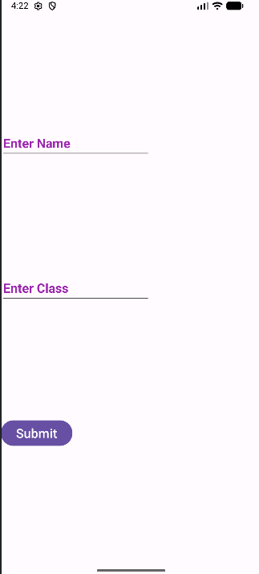

Practical No.14
Aim: Develop a program to implement Radio Button and Radio Group.
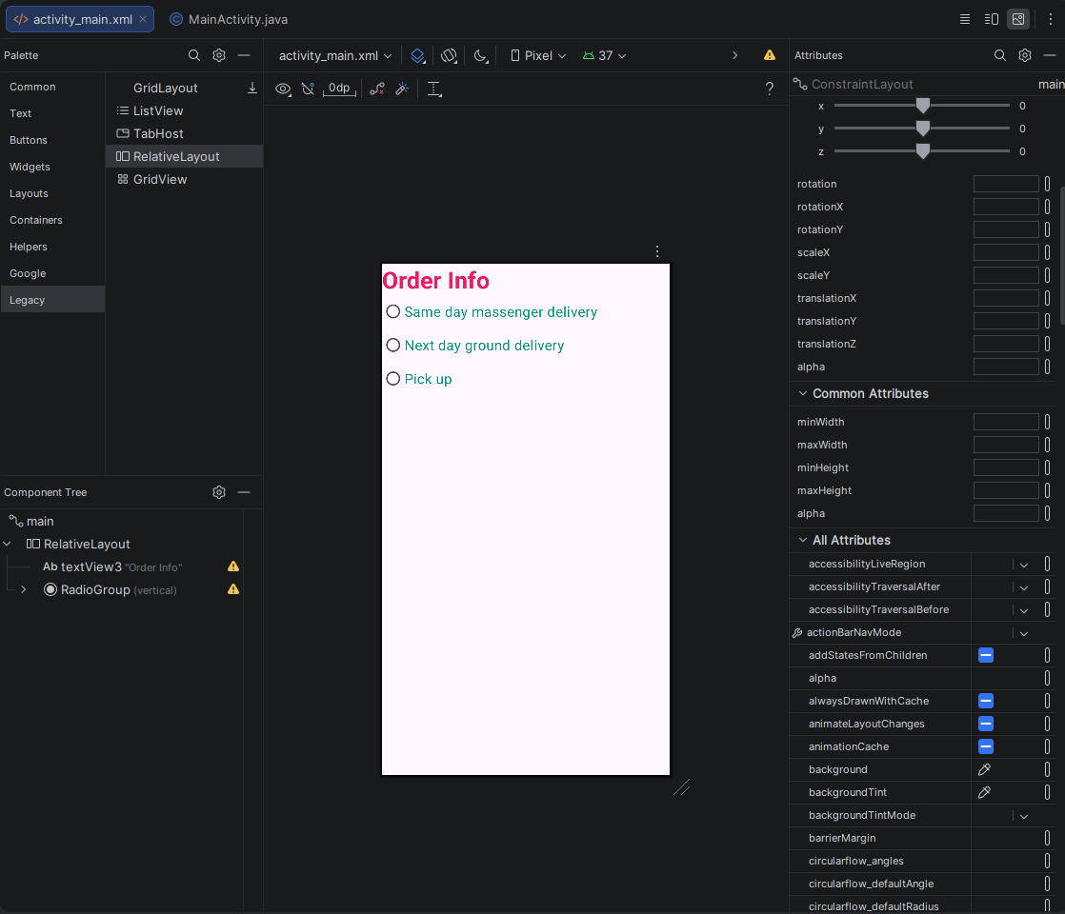

XML Code:
<?xml version="1.0" encoding="utf-8"?>
<androidx.constraintlayout.widget.ConstraintLayout xmlns:android="http://schemas.android.com/apk/res/android"
xmlns:app="http://schemas.android.com/apk/res-auto"
xmlns:tools="http://schemas.android.com/tools"
android:id="@+id/main"
android:layout_width="match_parent"
android:layout_height="match_parent"
tools:context=".MainActivity">

<RelativeLayout
android:layout_width="match_parent"
android:layout_height="match_parent">

<TextView
android:id="@+id/textView3"
android:layout_width="171dp"
android:layout_height="44dp"
android:text="Order Info"
android:textColor="#E91E63"
android:textSize="34sp"
android:textStyle="bold" />

<RadioGroup
android:layout_width="318dp"
android:layout_height="287dp"
android:layout_below="@id/textView3">

<RadioButton
android:id="@+id/radioButton6"
android:layout_width="match_parent"
android:layout_height="wrap_content"
android:text="Same day massenger delivery"
android:textColor="#009688"
android:textSize="20sp" />

<RadioButton
android:id="@+id/radioButton7"
android:layout_width="match_parent"
android:layout_height="wrap_content"
android:text="Next day ground delivery"
android:textColor="#009688"
android:textSize="20sp" />

<RadioButton
android:id="@+id/radioButton8"
android:layout_width="match_parent"
android:layout_height="wrap_content"
android:text="Pick up"
android:textColor="#009688"
android:textSize="20sp" />

</RadioGroup>
</RelativeLayout>

</androidx.constraintlayout.widget.ConstraintLayout>

Java Code:
package com.example.pract14_achal;

import android.os.Bundle;

import androidx.activity.EdgeToEdge;
import androidx.appcompat.app.AppCompatActivity;
import androidx.core.graphics.Insets;
import androidx.core.view.ViewCompat;
import androidx.core.view.WindowInsetsCompat;

public class MainActivity extends AppCompatActivity {

@Override
protected void onCreate(Bundle savedInstanceState) {
super.onCreate(savedInstanceState);
EdgeToEdge.enable(this);
setContentView(R.layout.activity_main);
ViewCompat.setOnApplyWindowInsetsListener(findViewById(R.id.main), (v, insets) -> {
Insets systemBars = insets.getInsets(WindowInsetsCompat.Type.systemBars());
v.setPadding(systemBars.left, systemBars.top, systemBars.right, systemBars.bottom);
return insets;
});
}
}

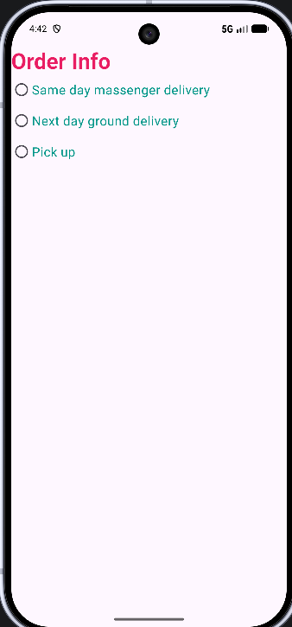
Practical No.12
Aim: Develop a program to implement login window using above UI controls.
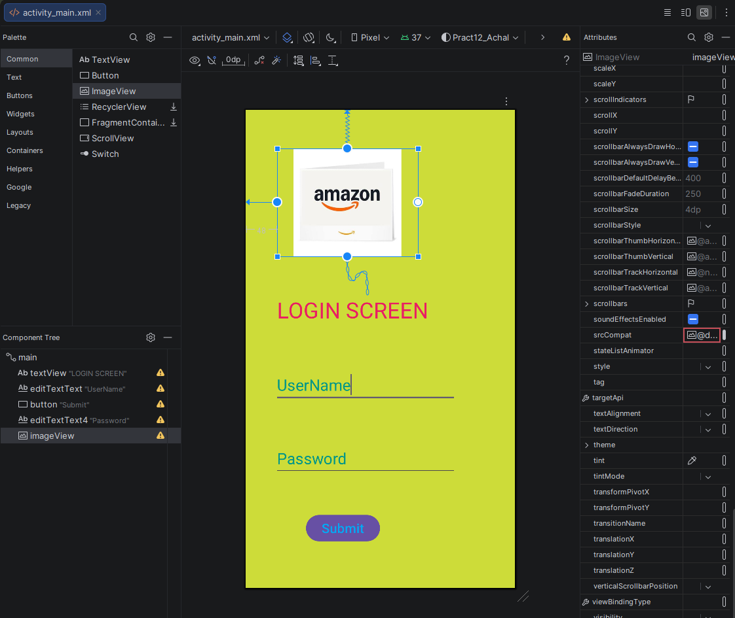

XML Code:
<?xml version="1.0" encoding="utf-8"?>
<androidx.constraintlayout.widget.ConstraintLayout xmlns:android="http://schemas.android.com/apk/res/android"
xmlns:app="http://schemas.android.com/apk/res-auto"
xmlns:tools="http://schemas.android.com/tools"
android:id="@+id/main"
android:layout_width="match_parent"
android:layout_height="match_parent"
android:background="#CDDC39"
tools:context=".MainActivity">

<TextView
android:id="@+id/textView"
android:layout_width="277dp"
android:layout_height="52dp"
android:layout_marginStart="48dp"
android:text="LOGIN SCREEN"
android:textColor="#E91E63"
android:textColorHint="#2196F3"
android:textSize="34sp"
app:layout_constraintBottom_toTopOf="@id/editTextText"
app:layout_constraintStart_toStartOf="parent"
app:layout_constraintTop_toBottomOf="@id/imageView" />

<EditText
android:id="@+id/editTextText"
android:layout_width="wrap_content"
android:layout_height="wrap_content"
android:layout_marginStart="44dp"
android:ems="10"
android:inputType="text"
android:text="UserName"
android:textColor="#009688"
android:textSize="24sp"
app:layout_constraintBottom_toTopOf="@id/editTextText4"
app:layout_constraintStart_toStartOf="parent"
app:layout_constraintTop_toBottomOf="@id/textView" />

<Button
android:id="@+id/button"
android:layout_width="wrap_content"
android:layout_height="wrap_content"
android:layout_marginStart="92dp"
android:text="Submit"
android:textColor="#03A9F4"
android:textSize="20sp"
app:layout_constraintBottom_toBottomOf="parent"
app:layout_constraintStart_toStartOf="parent"
app:layout_constraintTop_toBottomOf="@id/editTextText4"
app:layout_constraintVertical_bias="0.455" />

<EditText
android:id="@+id/editTextText4"
android:layout_width="wrap_content"
android:layout_height="wrap_content"
android:layout_marginStart="44dp"
android:ems="10"
android:inputType="text"
android:text="Password"
android:textColor="#009688"
android:textSize="24sp"
app:layout_constraintBottom_toBottomOf="parent"
app:layout_constraintStart_toStartOf="parent"
app:layout_constraintTop_toBottomOf="@id/textView" />

<ImageView
android:id="@+id/imageView"
android:layout_width="215dp"
android:layout_height="165dp"
android:layout_marginStart="48dp"
app:layout_constraintBottom_toTopOf="@id/textView"
app:layout_constraintStart_toStartOf="parent"
app:layout_constraintTop_toTopOf="parent"
app:srcCompat="@drawable/images" />

</androidx.constraintlayout.widget.ConstraintLayout>

Java Code:

Output:
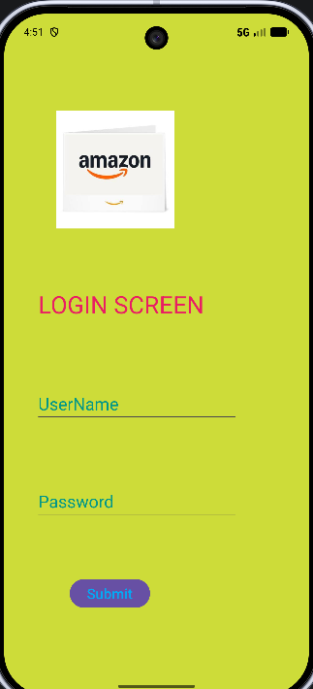

Practical No.15
Aim: Develop a program to create registration form.

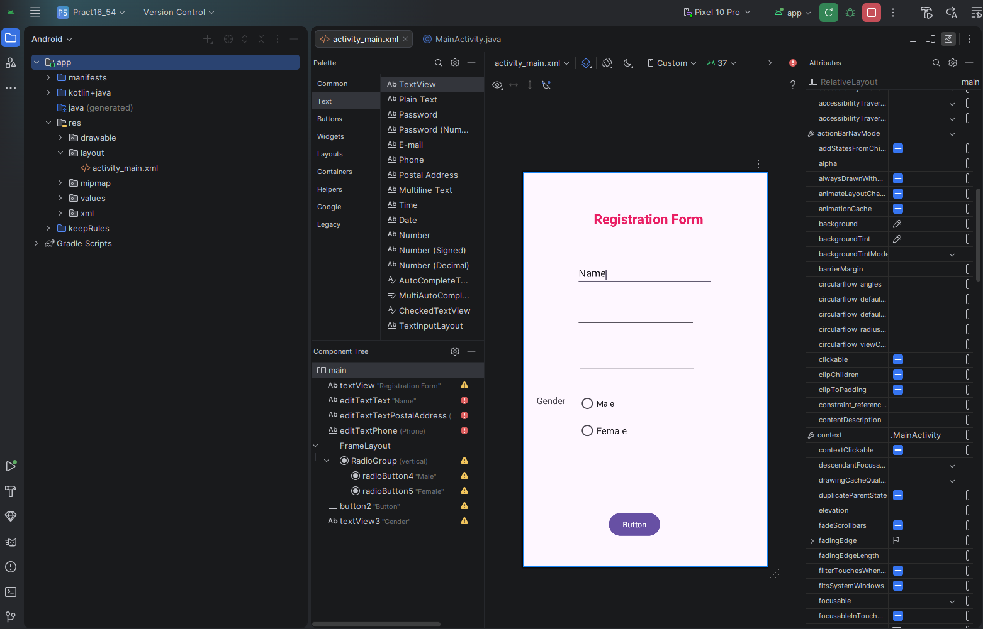
XML Code:
<?xml version="1.0" encoding="utf-8"?>
<android.widget.RelativeLayout xmlns:android="http://schemas.android.com/apk/res/android"
xmlns:app="http://schemas.android.com/apk/res-auto"
xmlns:tools="http://schemas.android.com/tools"
android:id="@+id/main"
android:layout_width="match_parent"
android:layout_height="match_parent"
tools:context=".MainActivity">
<TextView
android:id="@+id/textView"
android:layout_width="268dp"
android:layout_height="56dp"
android:layout_alignParentStart="true"
android:layout_alignParentTop="true"
android:layout_alignParentEnd="true"
android:layout_alignParentBottom="true"
android:layout_marginStart="88dp"
android:layout_marginTop="66dp"
android:layout_marginEnd="75dp"
android:layout_marginBottom="575dp"
android:text="Registration Form"
android:textAlignment="center"
android:textColor="#E91E63"
android:textSize="24sp"
android:textStyle="bold" />
<EditText
android:id="@+id/editTextText"
android:layout_width="241dp"
android:layout_height="38dp"
android:layout_alignParentStart="true"
android:layout_alignParentTop="true"
android:layout_alignParentEnd="true"
android:layout_alignParentBottom="true"
android:layout_marginStart="95dp"
android:layout_marginTop="163dp"
android:layout_marginEnd="95dp"
android:layout_marginBottom="496dp"
android:ems="10"
android:inputType="text"
android:text="Name" />
<EditText
android:id="@+id/editTextTextPostalAddress"
android:layout_width="wrap_content"
android:layout_height="wrap_content"
android:layout_alignParentEnd="true"
android:layout_alignParentBottom="true"
android:layout_marginEnd="127dp"
android:layout_marginBottom="423dp"
android:ems="10"
android:inputType="textPostalAddress" />
<EditText
android:id="@+id/editTextPhone"
android:layout_width="wrap_content"
android:layout_height="wrap_content"
android:layout_alignParentEnd="true"
android:layout_alignParentBottom="true"
android:layout_marginEnd="124dp"
android:layout_marginBottom="342dp"
android:ems="10"
android:inputType="phone" />
<FrameLayout
android:layout_width="222dp"
android:layout_height="174dp"
android:layout_alignParentEnd="true"
android:layout_alignParentBottom="true"
android:layout_marginEnd="111dp"
android:layout_marginBottom="138dp">
<RadioGroup
android:layout_width="match_parent"
android:layout_height="match_parent" >
<RadioButton
android:id="@+id/radioButton4"
android:layout_width="match_parent"
android:layout_height="wrap_content"
android:text="Male"
android:textSize="14sp" />
<RadioButton
android:id="@+id/radioButton5"
android:layout_width="match_parent"
android:layout_height="wrap_content"
android:text="Female"
android:textSize="16sp" />
</RadioGroup>
</FrameLayout>
<Button
android:id="@+id/button2"
android:layout_width="wrap_content"
android:layout_height="wrap_content"
android:layout_alignParentEnd="true"
android:layout_alignParentBottom="true"
android:layout_marginEnd="188dp"
android:layout_marginBottom="50dp"
android:onClick="showMessage"
android:text="Button" />
<TextView
android:id="@+id/textView3"
android:layout_width="78dp"
android:layout_height="26dp"
android:layout_alignParentEnd="true"
android:layout_alignParentBottom="true"
android:layout_marginEnd="342dp"
android:layout_marginBottom="278dp"
android:text="Gender"
android:textAlignment="center"
android:textSize="16sp" />
</android.widget.RelativeLayout>
Java Code:
package com.interview.pract16_54;

import android.os.Bundle;
import android.view.View;
import android.widget.RadioButton;
import android.widget.TextView;
import android.widget.Toast;

import androidx.activity.EdgeToEdge;
import androidx.appcompat.app.AppCompatActivity;
import androidx.core.graphics.Insets;
import androidx.core.view.ViewCompat;
import androidx.core.view.WindowInsetsCompat;

public class MainActivity extends AppCompatActivity {

@Override
protected void onCreate(Bundle savedInstanceState) {
super.onCreate(savedInstanceState);
EdgeToEdge.enable(this);
setContentView(R.layout.activity_main);
ViewCompat.setOnApplyWindowInsetsListener(findViewById(R.id.main), (v, insets) -> {
Insets systemBars = insets.getInsets(WindowInsetsCompat.Type.systemBars());
v.setPadding(systemBars.left, systemBars.top, systemBars.right, systemBars.bottom);
return insets;
});
}
public void showMessage(View view)
{
((TextView)findViewById(R.id.editTextText)).setText(" ");
((TextView)findViewById(R.id.editTextTextPostalAddress)).setText(" ");
((TextView)findViewById(R.id.editTextPhone)).setText(" ");
((RadioButton)findViewById(R.id.radioButton4)).setChecked((false));
((RadioButton)findViewById(R.id.radioButton5)).setChecked((false));
Toast.makeText(MainActivity.this,"Registration Successfully",Toast.LENGTH_LONG).show();
}
}
Output:

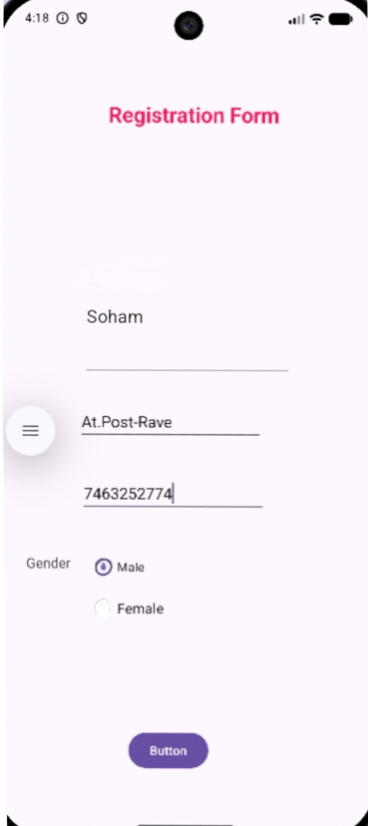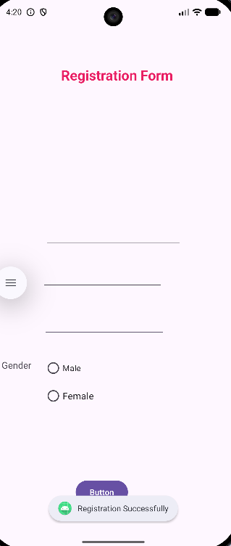
Practical No.16
Aim: Develop a program to implement custom toast alert.
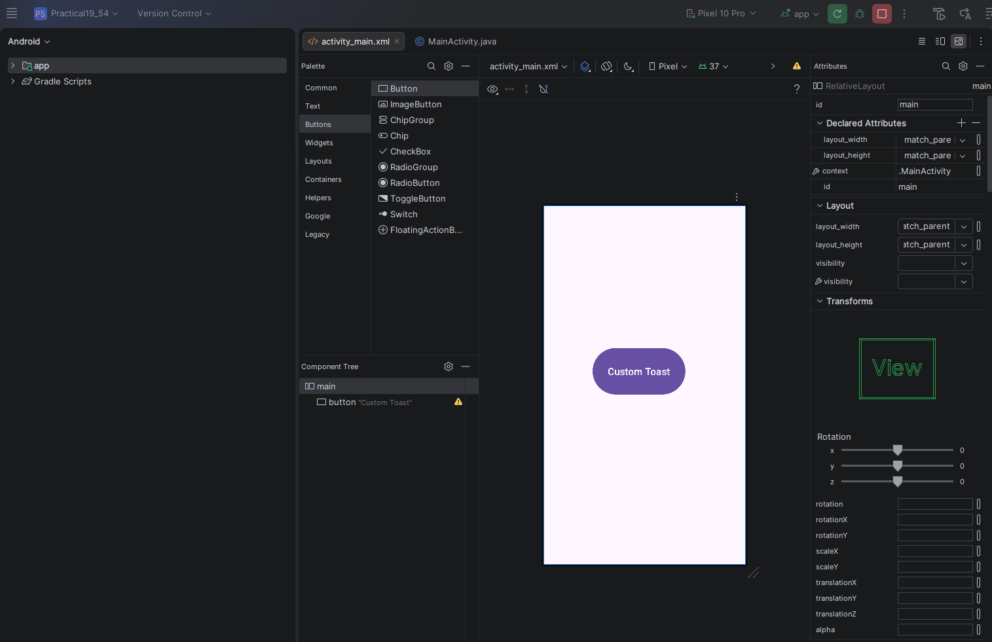
XML Code:
<?xml version="1.0" encoding="utf-8"?>
<android.widget.RelativeLayout xmlns:android="http://schemas.android.com/apk/res/android"
xmlns:app="http://schemas.android.com/apk/res-auto"
xmlns:tools="http://schemas.android.com/tools"
android:id="@+id/main"
android:layout_width="match_parent"
android:layout_height="match_parent"
tools:context=".MainActivity">
<Button
android:id="@+id/button"
android:layout_width="189dp"
android:layout_height="102dp"
android:layout_alignParentStart="true"
android:layout_alignParentTop="true"
android:layout_alignParentEnd="true"
android:layout_alignParentBottom="true"
android:layout_marginStart="100dp"
android:layout_marginTop="287dp"
android:layout_marginEnd="122dp"
android:layout_marginBottom="342dp"
android:onClick="showToast"
android:text="Custom Toast"
android:textAlignment="center"
android:textSize="20sp"
app:layout_constraintBottom_toBottomOf="parent"
app:layout_constraintEnd_toEndOf="parent"
app:layout_constraintStart_toStartOf="parent"
app:layout_constraintTop_toTopOf="parent" />
</android.widget.RelativeLayout>

Java Code:
package com.interview.practical19_54;

import android.os.Bundle;
import android.view.View;
import android.widget.Toast;

import androidx.activity.EdgeToEdge;
import androidx.appcompat.app.AppCompatActivity;
import androidx.core.graphics.Insets;
import androidx.core.view.ViewCompat;
import androidx.core.view.WindowInsetsCompat;

public class MainActivity extends AppCompatActivity {

@Override
protected void onCreate(Bundle savedInstanceState) {
super.onCreate(savedInstanceState);
EdgeToEdge.enable(this);
setContentView(R.layout.activity_main);
ViewCompat.setOnApplyWindowInsetsListener(findViewById(R.id.main), (v, insets) -> {
Insets systemBars = insets.getInsets(WindowInsetsCompat.Type.systemBars());
v.setPadding(systemBars.left, systemBars.top, systemBars.right, systemBars.bottom);
return insets;
});
}
public void showToast(View view)
{
Toast.makeText(MainActivity.this,"This is a normal toast",Toast.LENGTH_LONG).show();
}
}

Output:
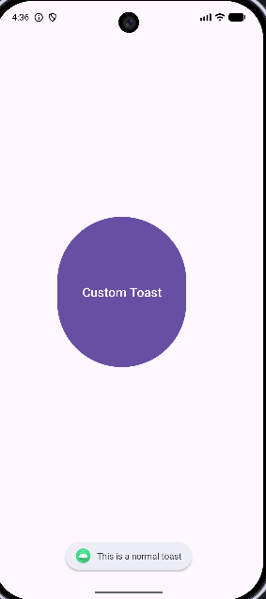

Practical No.17
Aim: Develop a program to implement Progress Bar.
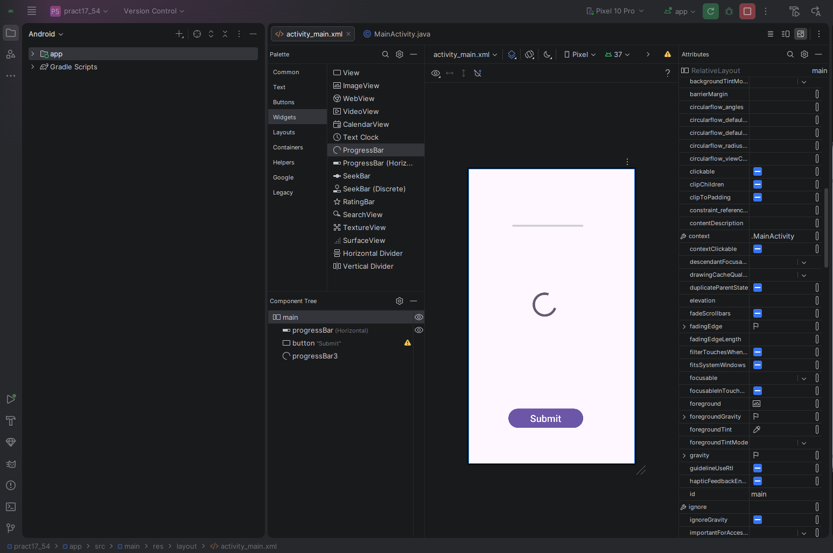
XML Code:
<?xml version="1.0" encoding="utf-8"?>
<android.widget.RelativeLayout xmlns:android="http://schemas.android.com/apk/res/android"
xmlns:app="http://schemas.android.com/apk/res-auto"
xmlns:tools="http://schemas.android.com/tools"
android:id="@+id/main"
android:layout_width="match_parent"
android:layout_height="match_parent"
android:visibility="visible"
tools:context=".MainActivity">
<ProgressBar
android:id="@+id/progressBar"
style="?android:attr/progressBarStyleHorizontal"
android:layout_width="175dp"
android:layout_height="53dp"
android:layout_alignParentStart="true"
android:layout_alignParentTop="true"
android:layout_alignParentEnd="true"
android:layout_alignParentBottom="true"
android:layout_marginStart="94dp"
android:layout_marginTop="120dp"
android:layout_marginEnd="142dp"
android:layout_marginBottom="558dp"
android:visibility="visible"
app:layout_constraintBottom_toBottomOf="parent"
app:layout_constraintEnd_toEndOf="parent"
app:layout_constraintHorizontal_bias="0.498"
app:layout_constraintStart_toStartOf="parent"
app:layout_constraintTop_toTopOf="parent"
app:layout_constraintVertical_bias="0.196" />
<Button
android:id="@+id/button"
android:layout_width="185dp"
android:layout_height="55dp"
android:layout_alignParentStart="true"
android:layout_alignParentTop="true"
android:layout_alignParentEnd="true"
android:layout_alignParentBottom="true"
android:layout_marginStart="99dp"
android:layout_marginTop="592dp"
android:layout_marginEnd="127dp"
android:layout_marginBottom="84dp"
android:onClick="progressStatus"
android:text="Submit"
android:textSize="24sp"
app:layout_constraintBottom_toBottomOf="parent"
app:layout_constraintEnd_toEndOf="parent"
app:layout_constraintHorizontal_bias="0.498"
app:layout_constraintStart_toStartOf="parent"
app:layout_constraintTop_toTopOf="parent"
app:layout_constraintVertical_bias="0.673" />
<ProgressBar
android:id="@+id/progressBar3"
style="?android:attr/progressBarStyle"
android:layout_width="100dp"
android:layout_height="72dp"
android:layout_alignParentEnd="true"
android:layout_alignParentBottom="true"
android:layout_marginEnd="172dp"
android:layout_marginBottom="358dp" />
</android.widget.RelativeLayout>
Java Code:
package com.interview.pract17_54;

import android.os.Bundle;
import android.view.View;
import android.widget.ProgressBar;

import androidx.activity.EdgeToEdge;
import androidx.appcompat.app.AppCompatActivity;
import androidx.core.graphics.Insets;
import androidx.core.view.ViewCompat;
import androidx.core.view.WindowInsetsCompat;

public class MainActivity extends AppCompatActivity {

@Override
protected void onCreate(Bundle savedInstanceState) {
super.onCreate(savedInstanceState);
EdgeToEdge.enable(this);
setContentView(R.layout.activity_main);
ViewCompat.setOnApplyWindowInsetsListener(findViewById(R.id.main), (v, insets) -> {
Insets systemBars = insets.getInsets(WindowInsetsCompat.Type.systemBars());
v.setPadding(systemBars.left, systemBars.top, systemBars.right, systemBars.bottom);
return insets;
});
}
public void progressStatus(View view)
{
ProgressBar progbar=findViewById(R.id.progressBar);
progbar.setProgress(50);

ProgressBar progressBar=findViewById(R.id.progressBar3);
progressBar.setVisibility(View.VISIBLE);
}
}

Output:
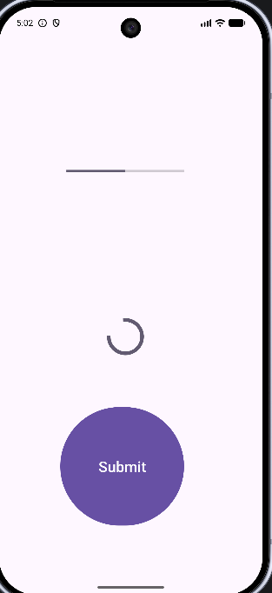

Practical No.13
Aim: Develop a program to implement checkbox.
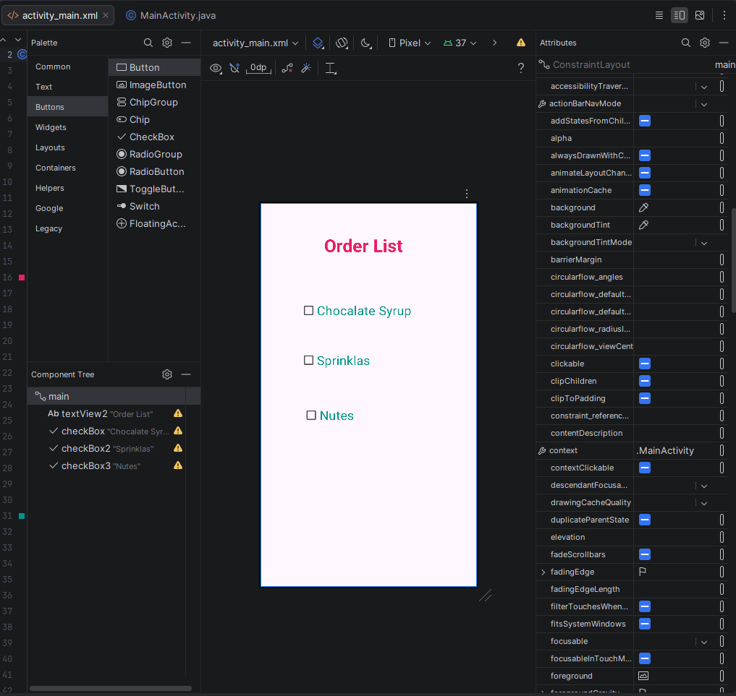
XML Code:
<?xml version="1.0" encoding="utf-8"?>
<androidx.constraintlayout.widget.ConstraintLayout xmlns:android="http://schemas.android.com/apk/res/android"
xmlns:app="http://schemas.android.com/apk/res-auto"
xmlns:tools="http://schemas.android.com/tools"
android:id="@+id/main"
android:layout_width="match_parent"
android:layout_height="match_parent"
tools:context=".MainActivity">
<TextView
android:id="@+id/textView2"
android:layout_width="193dp"
android:layout_height="52dp"
android:text="Order List"
android:textAlignment="center"
android:textColor="#E91E63"
android:textSize="34sp"
android:textStyle="bold"
app:layout_constraintBottom_toBottomOf="parent"
app:layout_constraintEnd_toEndOf="parent"
app:layout_constraintHorizontal_bias="0.458"
app:layout_constraintStart_toStartOf="parent"
app:layout_constraintTop_toTopOf="parent"
app:layout_constraintVertical_bias="0.085" />
<CheckBox
android:id="@+id/checkBox"
android:layout_width="225dp"
android:layout_height="64dp"
android:text="Chocalate Syrup"
android:textColor="#009688"
android:textSize="24sp"
app:layout_constraintBottom_toBottomOf="parent"
app:layout_constraintEnd_toEndOf="parent"
app:layout_constraintHorizontal_bias="0.407"
app:layout_constraintStart_toStartOf="parent"
app:layout_constraintTop_toTopOf="parent"
app:layout_constraintVertical_bias="0.259" />
<CheckBox
android:id="@+id/checkBox2"
android:layout_width="151dp"
android:layout_height="68dp"
android:text="Sprinklas"
android:textColor="#009688"
android:textSize="24sp"
app:layout_constraintBottom_toBottomOf="parent"
app:layout_constraintEnd_toEndOf="parent"
app:layout_constraintHorizontal_bias="0.291"
app:layout_constraintStart_toStartOf="parent"
app:layout_constraintTop_toTopOf="parent"
app:layout_constraintVertical_bias="0.401" />
<CheckBox
android:id="@+id/checkBox3"
android:layout_width="148dp"
android:layout_height="58dp"
android:text="Nutes"
android:textColor="#009688"
android:textSize="24sp"
app:layout_constraintBottom_toBottomOf="parent"
app:layout_constraintEnd_toEndOf="parent"
app:layout_constraintHorizontal_bias="0.307"
app:layout_constraintStart_toStartOf="parent"
app:layout_constraintTop_toTopOf="parent"
app:layout_constraintVertical_bias="0.558" />
</androidx.constraintlayout.widget.ConstraintLayout>

Java Code:
package com.example.pract13_achal;
import android.os.Bundle;
import androidx.activity.EdgeToEdge;
import androidx.appcompat.app.AppCompatActivity;
import androidx.core.graphics.Insets;
import androidx.core.view.ViewCompat;
import androidx.core.view.WindowInsetsCompat;
public class MainActivity extends AppCompatActivity {
@Override
protected void onCreate(Bundle savedInstanceState) {
super.onCreate(savedInstanceState);
EdgeToEdge.enable(this);
setContentView(R.layout.activity_main);
ViewCompat.setOnApplyWindowInsetsListener(findViewById(R.id.main), (v, insets) -> {
Insets systemBars = insets.getInsets(WindowInsetsCompat.Type.systemBars());
v.setPadding(systemBars.left, systemBars.top, systemBars.right, systemBars.bottom);
return insets;
});
}
}
Output:
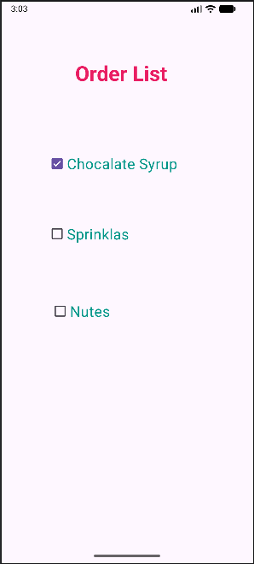

Practical No.8
Aim: Develop a program to implement Frame Layout.
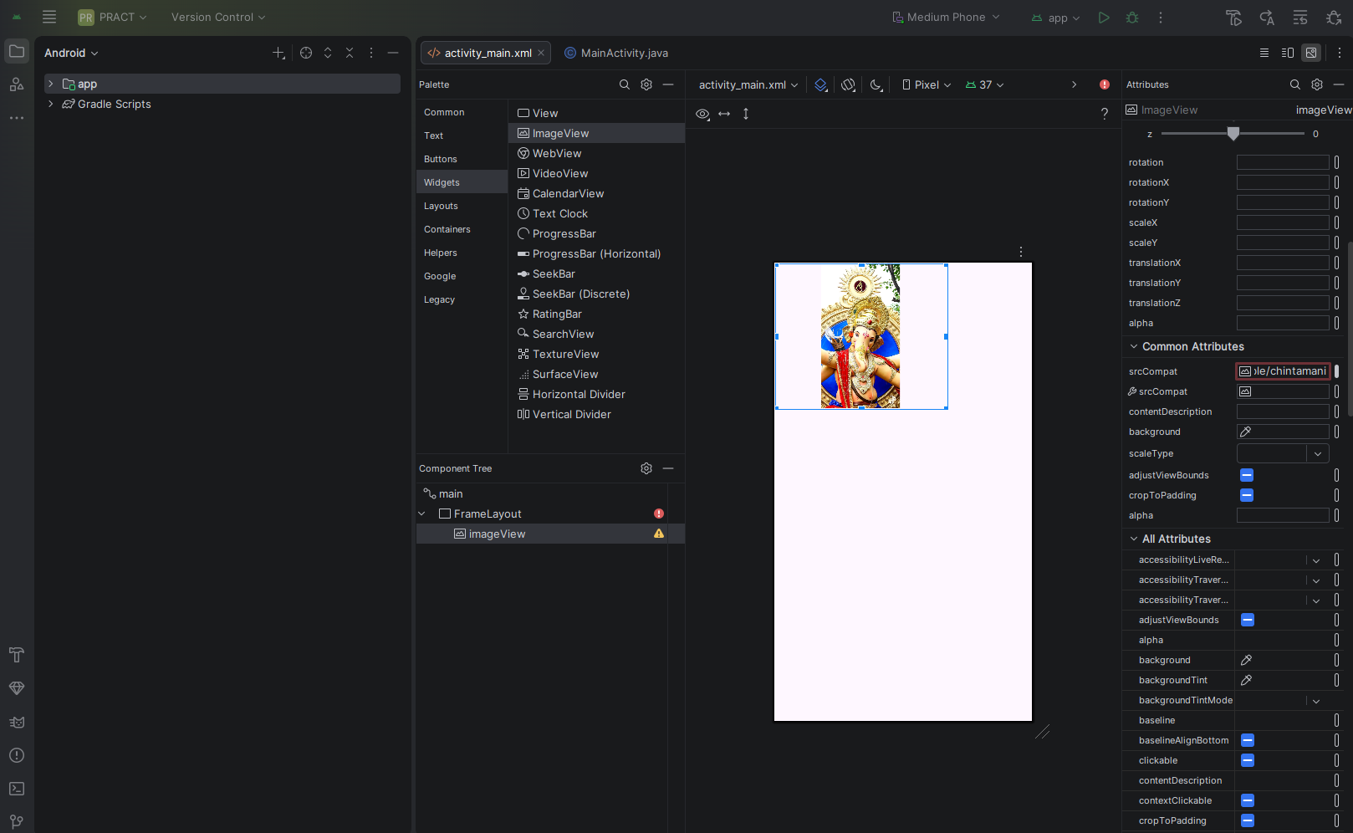
Xml Code:
<?xml version="1.0" encoding="utf-8"?>
<androidx.constraintlayout.widget.ConstraintLayout xmlns:android="http://schemas.android.com/apk/res/android"
xmlns:app="http://schemas.android.com/apk/res-auto"
xmlns:tools="http://schemas.android.com/tools"
android:id="@+id/main"
android:layout_width="match_parent"
android:layout_height="match_parent"
tools:context=".MainActivity">
<FrameLayout
android:layout_width="274dp"
android:layout_height="232dp"
tools:layout_editor_absoluteX="1dp"
tools:layout_editor_absoluteY="1dp">
<ImageView
android:id="@+id/imageView"
android:layout_width="wrap_content"
android:layout_height="wrap_content"
app:srcCompat="@drawable/chintamani" />
</FrameLayout>
</androidx.constraintlayout.widget.ConstraintLayout>
Java Code:
package com.example.pract;
import android.os.Bundle;
import androidx.activity.EdgeToEdge;
import androidx.appcompat.app.AppCompatActivity;
import androidx.core.graphics.Insets;
import androidx.core.view.ViewCompat;
import androidx.core.view.WindowInsetsCompat;
public class MainActivity extends AppCompatActivity {
@Override
protected void onCreate(Bundle savedInstanceState) {
super.onCreate(savedInstanceState);
EdgeToEdge.enable(this);
setContentView(R.layout.activity_main);
ViewCompat.setOnApplyWindowInsetsListener(findViewById(R.id.main), (v, insets) -> {
Insets systemBars = insets.getInsets(WindowInsetsCompat.Type.systemBars());
v.setPadding(systemBars.left, systemBars.top, systemBars.right, systemBars.bottom);
return insets;
});
}
}

Output:


Practical No.4
Aim: Develop a program to display Hello World on screen.
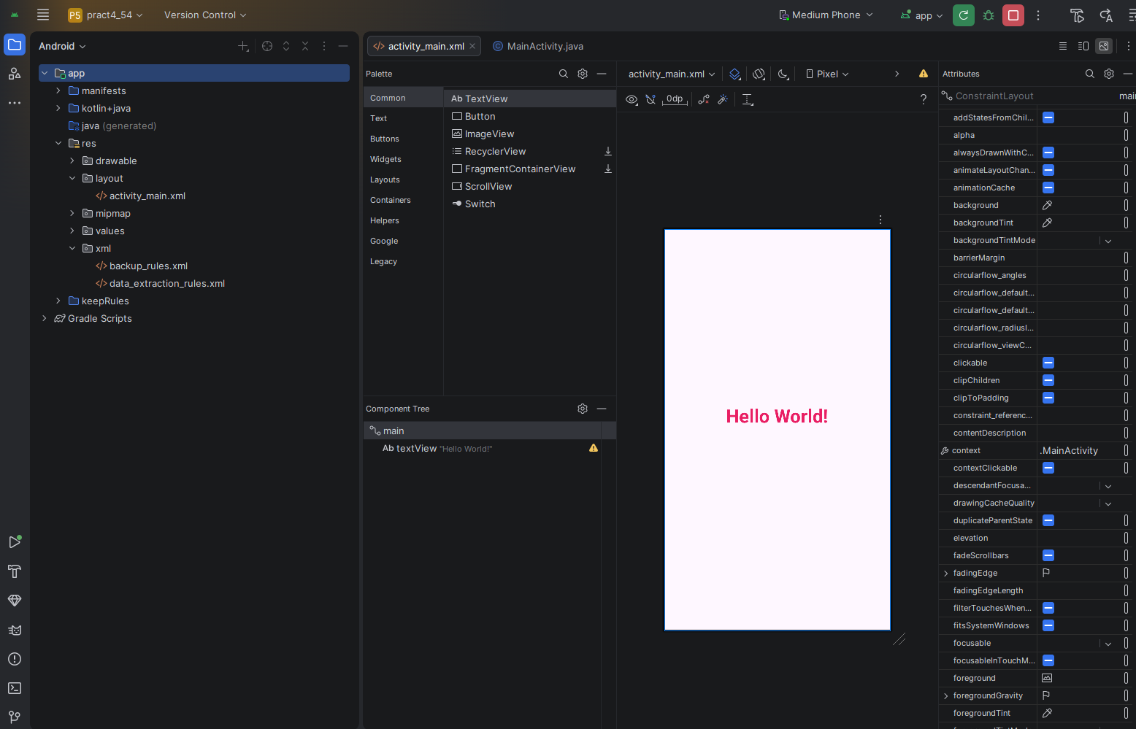
XML Code:
<?xml version="1.0" encoding="utf-8"?>
<androidx.constraintlayout.widget.ConstraintLayout xmlns:android="http://schemas.android.com/apk/res/android"
xmlns:app="http://schemas.android.com/apk/res-auto"
xmlns:tools="http://schemas.android.com/tools"
android:id="@+id/main"
android:layout_width="match_parent"
android:layout_height="match_parent"
tools:context=".MainActivity">
<TextView
android:id="@+id/textView"
android:layout_width="234dp"
android:layout_height="58dp"
android:text="Hello World!"
android:textAlignment="center"
android:textColor="#E91E63"
android:textSize="34sp"
android:textStyle="bold"
app:layout_constraintBottom_toBottomOf="parent"
app:layout_constraintEnd_toEndOf="parent"
app:layout_constraintHorizontal_bias="0.497"
app:layout_constraintStart_toStartOf="parent"
app:layout_constraintTop_toTopOf="parent"
app:layout_constraintVertical_bias="0.472" />
</androidx.constraintlayout.widget.ConstraintLayout>

Java Code:
package com.example.pract4_54;
import android.os.Bundle;
import androidx.activity.EdgeToEdge;
import androidx.appcompat.app.AppCompatActivity;
import androidx.core.graphics.Insets;
import androidx.core.view.ViewCompat;
import androidx.core.view.WindowInsetsCompat;
public class MainActivity extends AppCompatActivity {
@Override
protected void onCreate(Bundle savedInstanceState) {
super.onCreate(savedInstanceState);
EdgeToEdge.enable(this);
setContentView(R.layout.activity_main);
ViewCompat.setOnApplyWindowInsetsListener(findViewById(R.id.main), (v, insets) -> {
Insets systemBars = insets.getInsets(WindowInsetsCompat.Type.systemBars());
v.setPadding(systemBars.left, systemBars.top, systemBars.right, systemBars.bottom);
return insets;
});
}
}

Output:
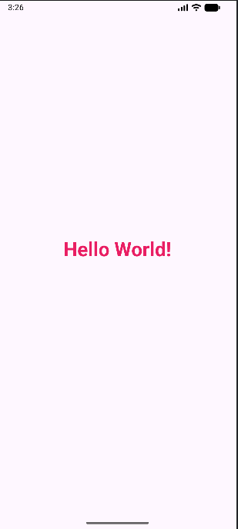

Practical No.11
Aim: Develop a program to implement image button and toggle button.
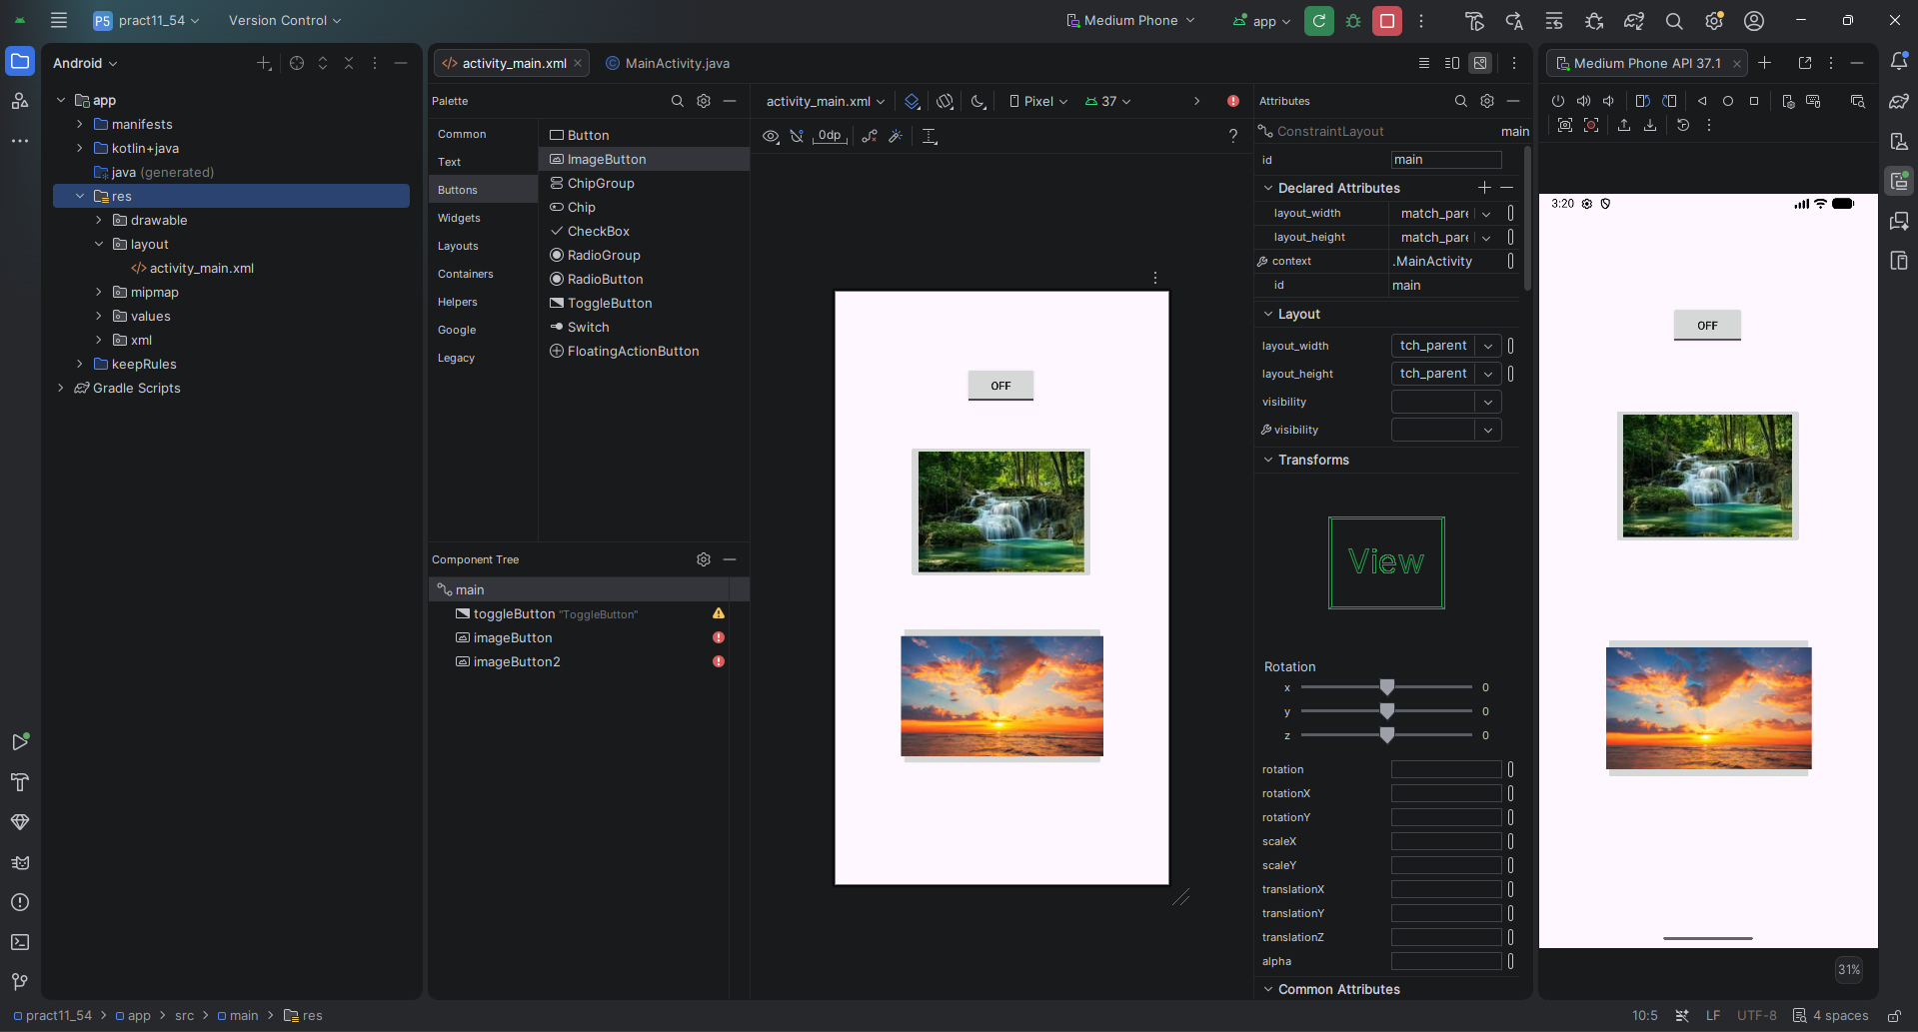
XML Code:
<?xml version="1.0" encoding="utf-8"?>
<androidx.constraintlayout.widget.ConstraintLayout xmlns:android="http://schemas.android.com/apk/res/android"
xmlns:app="http://schemas.android.com/apk/res-auto"
xmlns:tools="http://schemas.android.com/tools"
android:id="@+id/main"
android:layout_width="match_parent"
android:layout_height="match_parent"
tools:context=".MainActivity">
<ToggleButton
android:id="@+id/toggleButton"
android:layout_width="wrap_content"
android:layout_height="wrap_content"
android:text="ToggleButton"
app:layout_constraintBottom_toBottomOf="parent"
app:layout_constraintEnd_toEndOf="parent"
app:layout_constraintHorizontal_bias="0.498"
app:layout_constraintStart_toStartOf="parent"
app:layout_constraintTop_toTopOf="parent"
app:layout_constraintVertical_bias="0.136" />
<ImageButton
android:id="@+id/imageButton"
android:layout_width="wrap_content"
android:layout_height="wrap_content"
app:layout_constraintBottom_toBottomOf="parent"
app:layout_constraintEnd_toEndOf="parent"
app:layout_constraintHorizontal_bias="0.497"
app:layout_constraintStart_toStartOf="parent"
app:layout_constraintTop_toTopOf="parent"
app:layout_constraintVertical_bias="0.335"
app:srcCompat="@drawable/waterfall" />
<ImageButton
android:id="@+id/imageButton2"
android:layout_width="249dp"
android:layout_height="176dp"
app:layout_constraintBottom_toBottomOf="parent"
app:layout_constraintEnd_toEndOf="parent"
app:layout_constraintHorizontal_bias="0.505"
app:layout_constraintStart_toStartOf="parent"
app:layout_constraintTop_toTopOf="parent"
app:layout_constraintVertical_bias="0.741"
app:srcCompat="@drawable/sunset" />
</androidx.constraintlayout.widget.ConstraintLayout>
Java Code:
package com.example.pract11_54;
import android.os.Bundle;
import androidx.activity.EdgeToEdge;
import androidx.appcompat.app.AppCompatActivity;
import androidx.core.graphics.Insets;
import androidx.core.view.ViewCompat;
import androidx.core.view.WindowInsetsCompat;
public class MainActivity extends AppCompatActivity {
@Override
protected void onCreate(Bundle savedInstanceState) {
super.onCreate(savedInstanceState);
EdgeToEdge.enable(this);
setContentView(R.layout.activity_main);
ViewCompat.setOnApplyWindowInsetsListener(findViewById(R.id.main), (v, insets) -> {
Insets systemBars = insets.getInsets(WindowInsetsCompat.Type.systemBars());
v.setPadding(systemBars.left, systemBars.top, systemBars.right, systemBars.bottom);
return insets;
});
}
}
Output:
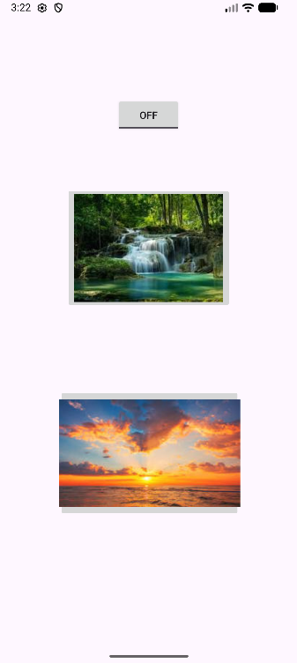
Practical No.18

